AIRPORT X

Sales Report

By: Stav Hefetz



Table Of Contents:

* PAGE 3: INTRO
* PAGE 4 – 8: BODY
* PAGE 9: CONCLUSIONS
* PAGE 10: APPENDIX

**Intro**

In this report, the Airport-X product team will evaluate and measure the success of different products the company offers, this will be done by exploring and analyzing a large amount of data that ranges between the purchases made from manufacturers and the eventual sales to the customers.

This report will explore a couple of key points:

How are the different products performing?

* What colors are most successful in the products?
* What is the most / least successful product category?
* Which gender buys more products, is the difference significant?
* Are there products that the company does not profit from?

Which manufacturer is more valuable to the company?

* Which manufacturer provides the company with the most successful products?
* Which manufacturer provides the company with the least successful products?
* Is there a significant difference between the generated revenue of the different brands?

Do the company products need more advertisements?

* Are there products in the company supply that don’t sell enough?
* Which product is the most sold?

**Body**

**How are the different products performing?**

To perform this research correctly the products that did profit must be eliminated first:

* 198,626 products did profit - 80.32% of the total
* 4610 products did not profit but also did not lose money - 1.86% of the total
* 44,055 products did not profit - 17.81% of the total

These values seem dangerous as there are many products that did not profit, **however** when looking at the company revenue as a whole, the company profited 7,033,149.35$

**Looking into the categories:**

The product team analyzed the revenue generated from different categories, this will help the management board decide which categories should be changed and in what way:

* Out of the eight categories, 4 categories were successful and profited more than 100,000$ each
* The slipper category performed the weakest and profited only 853$, much less compared to the other categories
* The sneakers category dominated here, generating 6,080,102$ - that’s 86.4% of the revenue generated

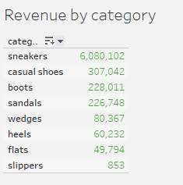

**Which colors are making the items more successful?**

Furthermore, the product team analyzed the profit generated by the different product colors, and found the following:

* Black colored products dominated the revenue generated significantly – 4,770,389$, that’s 67.82% of total revenue generated
* Out of 123 color categories, 92 color categories failed to generate more than 10,000$, that’s 73.17% of the total colors
* Below is a graph that emphasizes the profit by colors, and which colors were more dominant.

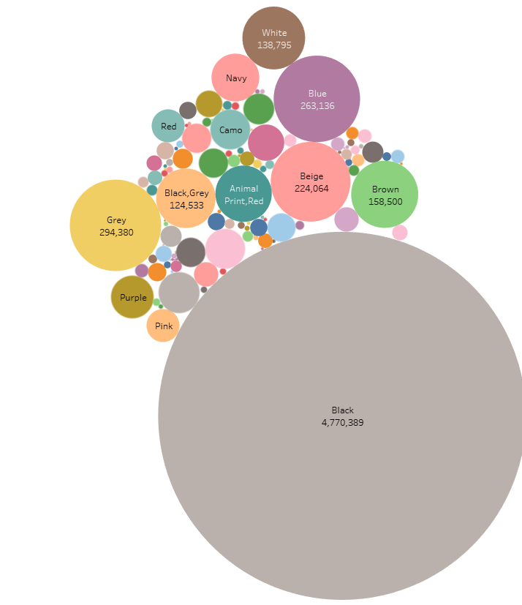

**Taking a look at item sales by gender:**

The product team wanted to check whether or not there is a significant difference between the revenue generated by products designed for the different gender, after processing the data, they found that:

* Male products generated 5,917,369$,
* female products generated 996,042$
* 119,730$ of the revenue were from unvalidated gender items
* The male products generated 70% more than the female products

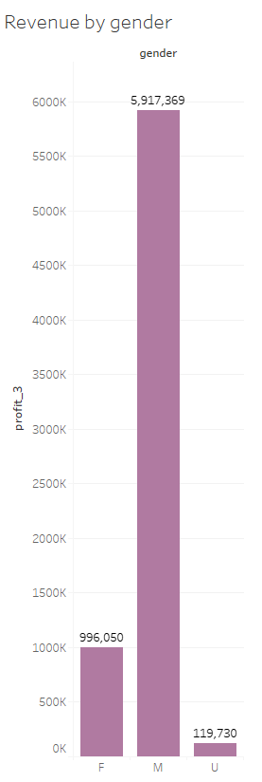

**Which manufacturer is more valuable to the company?**

Our company Imports products from 62 different manufacturers, the product team processed the data in order to find out which manufacturers are successful.

the management board is advised to continue cooperating with these manufacturers in the future:

* Adidas is the manufacturer which yielded the most revenue - 1,103,226$, followed by Nike – 850,834$; together, they make 27.77% of the total revenue
* Out of all of the brands, there are 27 brands that did not generate more than 10,000$, ---> 41% of the brands do not sell well.

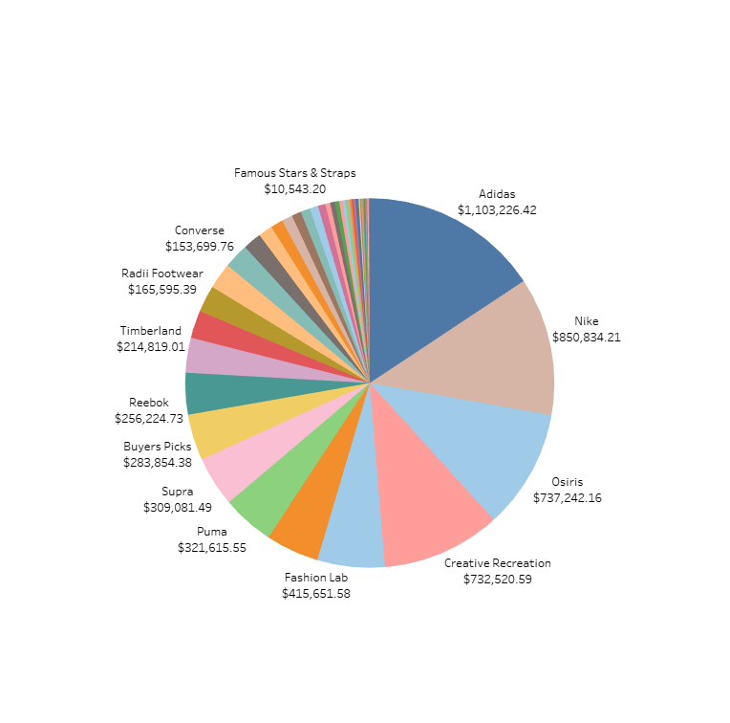

**Do the company products need more advertisements?**

Next, the product team wanted to examine whether or not there are products in the company’s supply that does not sell enough times, and on the other hand, check which items sell the most:

* The brand “NYC 83 sneakers” is dominating here, it claimed the first and second spot with a joined number of 305 units across all sizes
* The graph also shows how the top seller shoes are all sneakers
* There are 5044 products that sold less than 5 units, and they make up 91.64% of the total items
* On the other hand, there are 460 products who sold more than 5 units and they make 8.35% of the total items

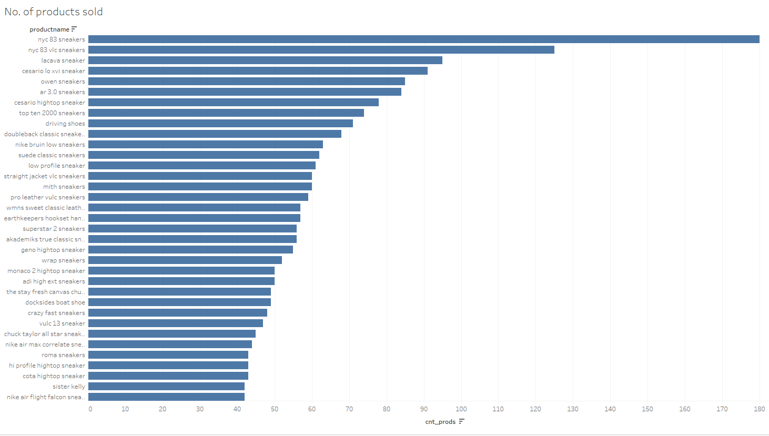

**Conclusions:**

* The dominating brands our company sells are Adidas and Nike
* The most successful item we have in inventory is the 83 NYC sneaker
* A big portion of our revenue is generated by a small percentage of items, it’s time to make a change.
* Our male designed products are dominating and generate a big part of our revenue compared to the female products
* Overall, the company is 7,033,149.35$ but based on this report, the management board can make changes which will increase this number even further

**Appendix:**

* Attached to this report is another word file containing all of the queries used to generate the conclusions presented above.
* In order to examine the different graphs in the tableau file, you need to copy the query into the custom SQL query button on the bottom left side of the software, this will unlock the different graphs in turn
* Also attached is a flowchart that helped me better understand the connection between the data
* Thank you for reading my report!!